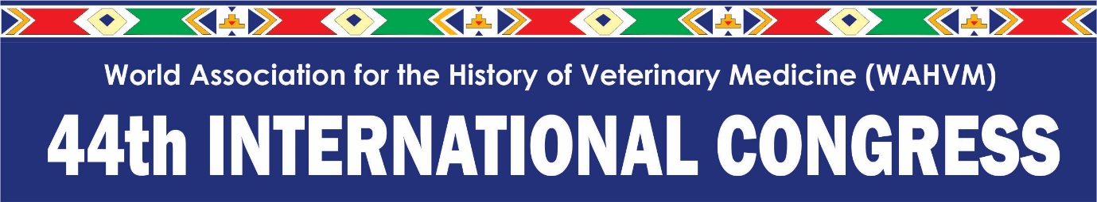

CALL FOR PAPERS

We are pleased to announce that abstract submissions are open for the 44th International Congress of the World Association for the History of Veterinary Medicine (WAHVM). The congress will be held from 27-29 February 2020 at the Farm Inn Hotel & Conference Centre in Pretoria, South Africa.

Registration for the congress will open soon – this will be communicated in due course.

The themes for this year's congress are “The Vet Histories of International Cooperation”, “Tropical Diseases” and “Free topics”. However, papers on other subjects are welcome and will be considered. All contributions should be based on historical methodology and should originate from unpublished work or provide an historical and not a technical review in respect of a component of the congress themes or the other subjects.

Please submit your abstracts to the 44th WAHVM Congress Organisers through email to Corné Engelbrecht at corne@savetcon.co.za. Kindly indicate the category your submission falls within.

The deadline for abstract submission is 30 November 2019.

NB: Please also submit a 1-page curriculum vitae (CV) of the presenting author with the abstract, as we require this for continuing education accreditation.

The format for abstracts submitted for approval is indicated below:

Abstract Submission Format Guidelines
- Abstracts must be limited to 350 words max.
- A minimum 2cm margin should be applied to the entire page.
- Use Arial font size 12 throughout the abstract.
- All of the abstract should be fully justified.
- Leave a blank line between each section if sections are used (Title, Authors, Contact details, Abstract, References (if applicable).
- Abstract to be accompanied by a one(1) page curriculum vitae (CV) of the presenting author
- Oral presentations will be allocated 25 minutes plus 5 minutes for discussion.
- Please ensure that the email addresses as submitted are correct as these addresses will be used in all correspondence and acceptance notifications.
- Late submissions will not be considered.
- Complete all information.

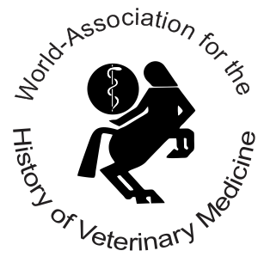

- Name and qualifications of presenter

- Contact details of presenter
(include address, phone and e-mail and current position (student/employed)

Address:
Organisation:
Phone: |  |  | Email:
Position: |  | Student* | Employed | Student number:
 |  | delete whichever not applicable | *if you have selected Student, please enter your student number above or provide copy of student card

- Category of Author (mark correct option with an X)

Amateur historian (contributing in their own way to the study of the history of veterinary medicine)
Early career scientist and/or students (present results of their studies)
Professional historian (present/report about their field of study, which is not related to the congress theme)
Poster (do not want to present orally or want to present results of work already published)
Other

If other__________________________________________________________

- Please insert your abstract in the space provide below

The deadline for abstract submission is 30 November 2019.

GUIDELINES FOR FULL PAPER/MANUSCRIPT PREPARATION FOR INCLUSION IN THE CONGRESS PROCEEDINGS

If your abstract is approved and placed in the programme we would require a manuscript for the congress book of proceedings.

In order to maintain uniformity in the publication of the Proceedings, speakers are asked to conform to the following guidelines in the preparation of their manuscripts:

Line one: Title, left aligned in BLOCK CAPITALS

Line two: Name of the author and qualification, left align

Line three: Address left align

Length: Not more than four pages (2000 words maximum), including figures and references, per presentation, which shall be representative of the full text of the lecture (not an abstract)

Format: Use A2 (21cm x 29.5cm) paper with standard margins.
Use 12pt Arial type (ten characters per inch or 2.5 cm).
Use single line spacing.
Diagrams, Tables, Drawings: Line drawings and graphs may be used. Any illustrations must be in black and white and as sharp as possible. Photographs or other illustrations should be in black and white.

Submission: All manuscripts should be submitted to the Scientific Committee by email.
The preferred programme is Microsoft Word.
A clear indication must be given as to the position of any illustrations in the text.
Deadline: all manuscript submissions must be sent to corne@savetcon.co.za by
14 February 2020.

